Antoine Gaton

Professor John Basco

CS361: Principles of User Interface Design

24 August 2024

***Unit 5 - Individual Project***

Evaluating user interfaces (UIs) requires more than just subjective opinions, it involves analyzing the functionality, usability, and overall experience that the interface provides. In this paper, I will explore three different types of user interfaces, Graphical User Interface (GUI), form-based user interface, and menu-driven user interface, by selecting one example for each. I will explain why these specific websites were chosen, discuss whether they might incorporate more than one UI type, and evaluate if the chosen UI type is the most appropriate for each example.

1. Selected Websites and UI Types
   1. Graphical User Interface (GUI)
      1. Website: Airbnb - <https://www.airbnb.com/>

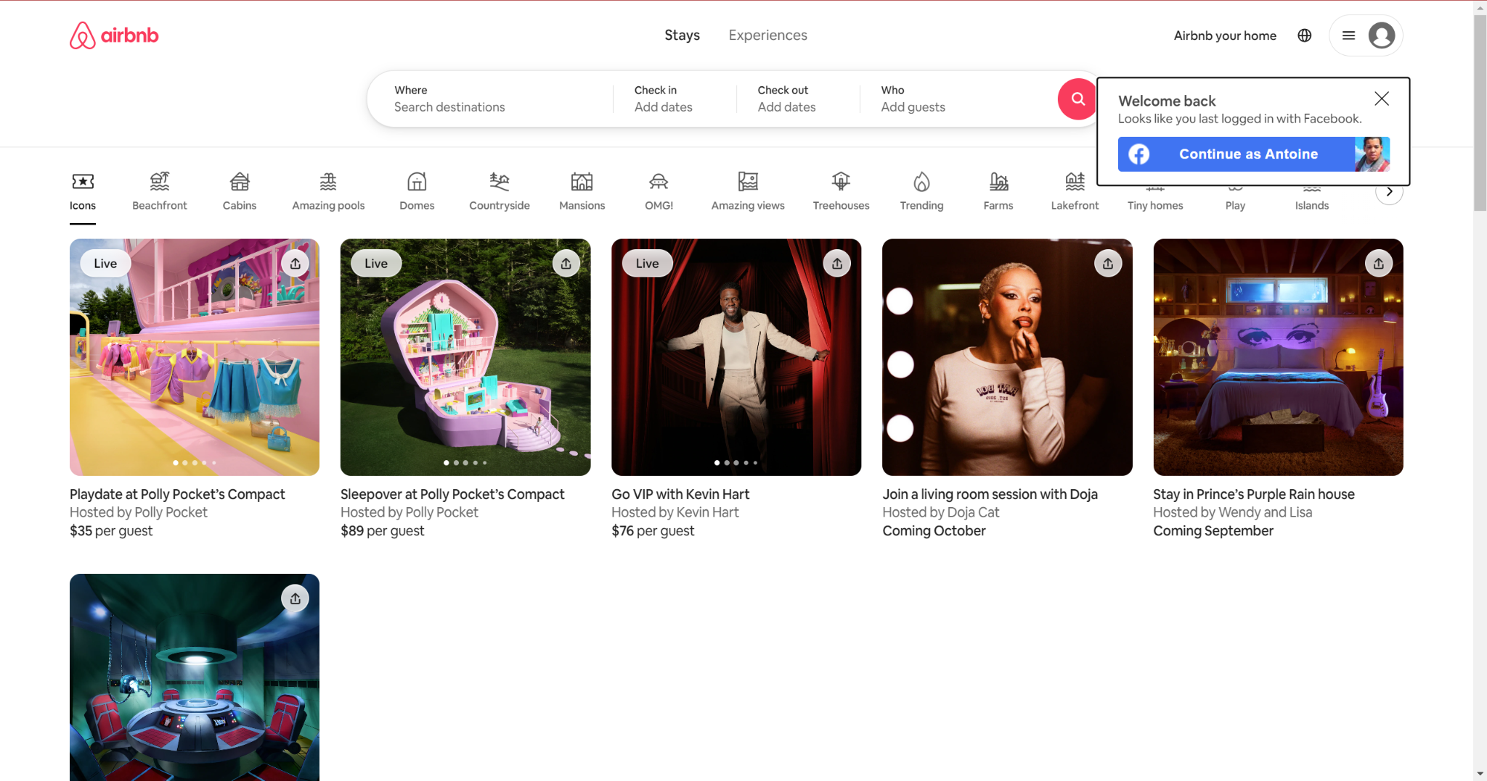

* + 1. Reason for Selection
       1. Airbnb's website is a prime example of a well-designed GUI. The site is visually rich, with an emphasis on images, icons, and interactive elements that guide users through the process of finding and booking accommodations. The interface relies heavily on graphical components such as maps, image carousels, and visually distinct buttons, making it an intuitive experience for users.
    2. Could Airbnb Incorporate More UI Types?
       1. Yes, Airbnb’s website could be considered to incorporate elements of a form-based interface, especially during the booking process where users fill in forms with their details and preferences. However, its core interface remains graphical, focused on delivering a visually appealing and interactive experience.
    3. Is GUI the Correct Choice?
       1. Absolutely! A GUI is the most appropriate choice for Airbnb because it leverages visual elements to create an engaging and user-friendly experience, crucial for a platform that relies on high-quality imagery and detailed listings to attract users.
  1. Form-Based User Interface
     1. Website: IRS.gov - <https://www.irs.gov/>

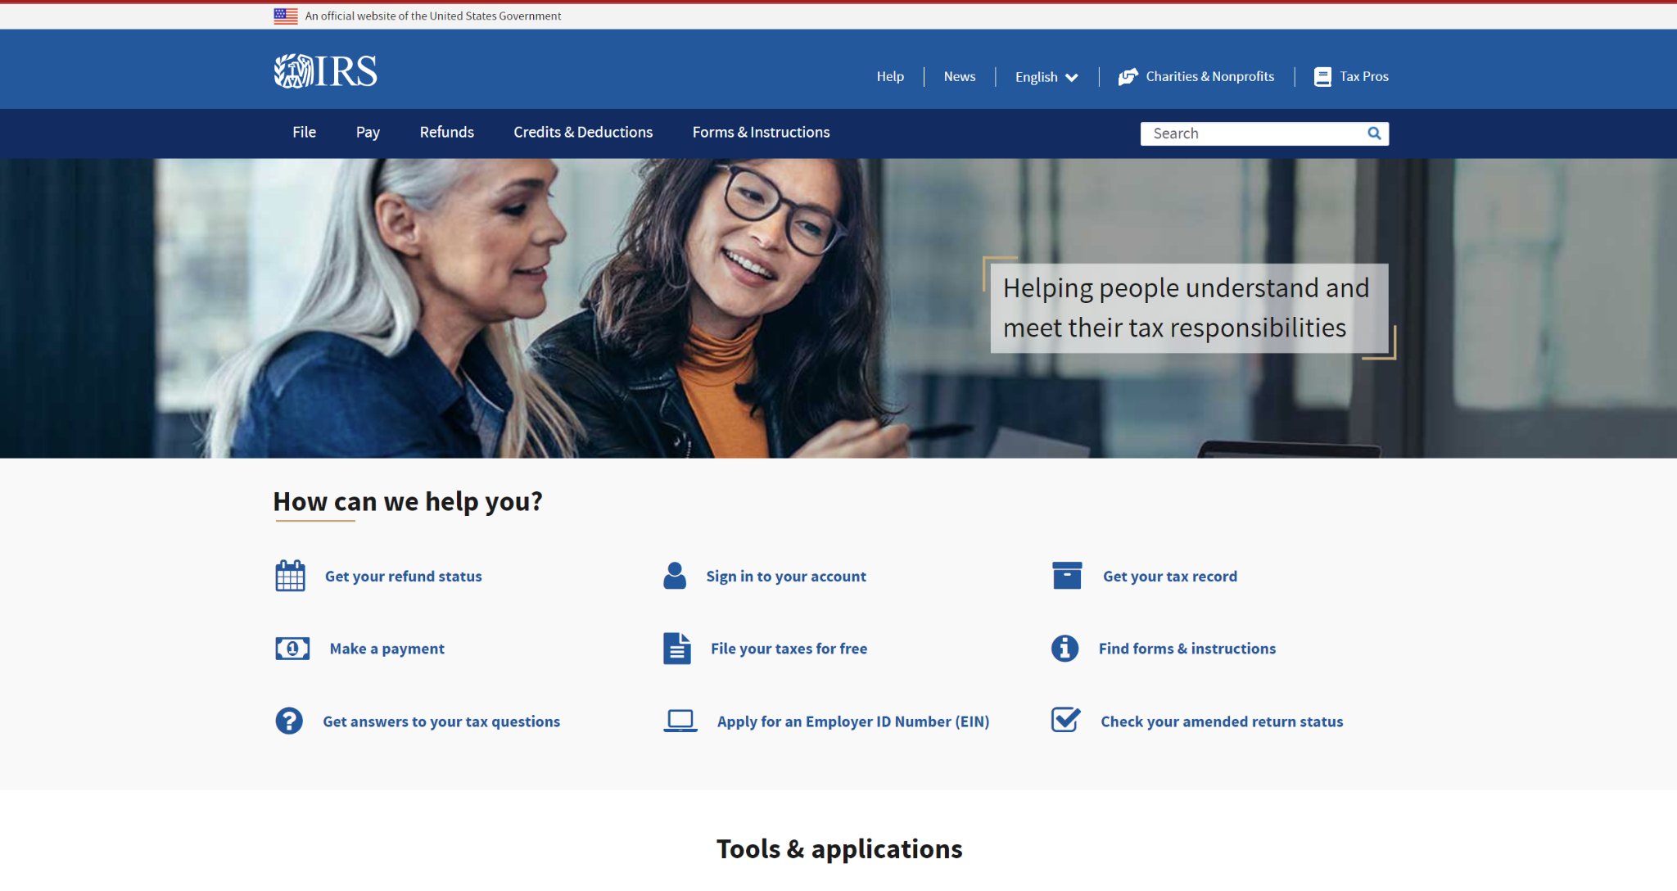

* + 1. Reason for Selection
       1. The IRS website is an example of a form-based user interface where users primarily interact with the site by filling out various forms. Whether filing taxes, applying for an EIN, or checking refund status, the user’s journey involves completing multiple forms, which are central to the interface.
    2. Could IRS.gov Incorporate More UI Types?
       1. While IRS.gov predominantly uses a form-based interface, it also includes menu-driven elements for navigation. However, the core functionality revolves around form completion.
    3. Is Form-Based UI the Correct Choice?
       1. Yes, the form-based interface is well-suited for IRS.gov because it efficiently handles data entry tasks that are critical for the site’s primary functions, filing taxes and processing financial information.
  1. Menu-Driven User Interface
     1. Website: McDonald’s - <https://www.mcdonalds.com/>

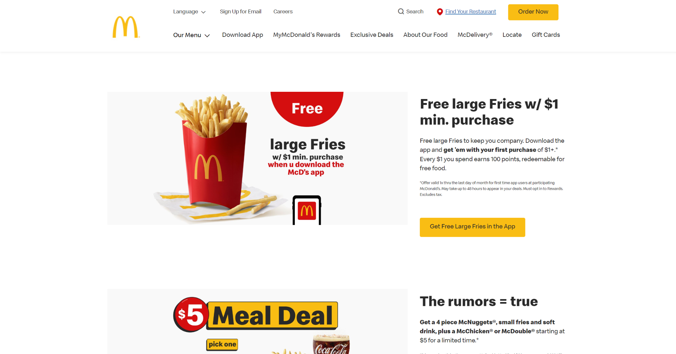

* + 1. Reason for Selection
       1. McDonald’s online ordering system exemplifies a menu-driven user interface. The site guides users through the ordering process using a series of menus that categorize food items and allow users to customize their orders.
    2. Could McDonald’s Incorporate More UI Types?
       1. The McDonald’s website also incorporates GUI elements, particularly in how it displays images of menu items and allows for customization. However, the primary interaction is menu-driven.
    3. Is Menu-Driven UI the Correct Choice?
       1. Yes, a menu-driven interface is ideal for McDonald’s as it organizes its extensive product offerings into manageable categories, simplifying the ordering process for users.

The three websites selected, Airbnb, IRS.gov, and McDonald’s, each represent different types of user interfaces: GUI, form-based, and menu-driven, respectively. While these sites incorporate elements from other UI types, their primary interfaces are well-suited to their purposes. Airbnb’s GUI facilitates a visually engaging experience, IRS.gov’s form-based interface efficiently handles complex data entry tasks, and McDonald’s menu-driven interface streamlines the ordering process. These choices highlight how different UI types can be effectively applied to meet specific user needs and enhance the overall experience.